**Wamser Batra – Monthly Health Report**

Prepared for

WB

Version 1.0

Date: 20.12.2022

Prepared by

JAY PRAKASH

Consultant-Cloud

Jay.prakash@cloudtechhacks.com

Contents

1. Introduction………………………………………………………………………………………………………………………….
   1. Executive Summary……………………………………………………………………………………………………….
   2. VM CPU Utilization……………………………………………………………………………………………………………….
   3. VM Memory Utilization……………………………………………………………………………………………………….
   4. Network in Utilization………………………………………………………………………………......................
   5. Network Out Utilization…………………………………………………………………………………………………
   6. VM Backup…………………………………………………………………………………………………………………….
   7. Database Data Storage Chart…………………………………………………………………………………………
   8. SQL CPU Utilization………………………………………………………………………………………………………..
   9. DTU Utilization………………………………………………………………………………………………………………
   10. SQL Backup…………………………………………………………………………………………………………………….

# Introduction

## Executive Summary

This is a Monthly report of NAV Server hosted on Azure for the period 01st December – 31st December 2022

## 1.2 VM CPU Utilization

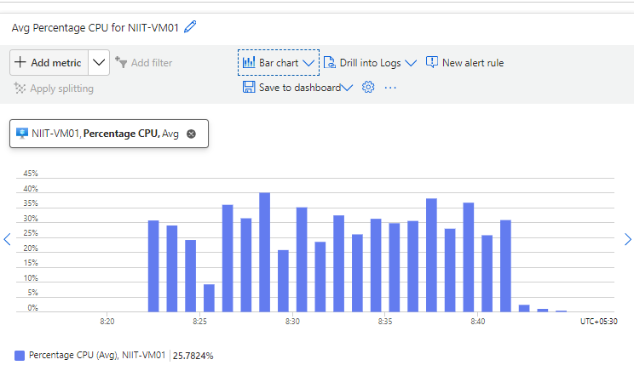Following is the **WBCI-PROD-APPVM01** CPU Utilization for the report period 01st December – 31st December 2022.

## VM Memory Utilization

Following is the **PROD-APPVM01** Memory Utilization for the report period 01st December – 31st December 2022.

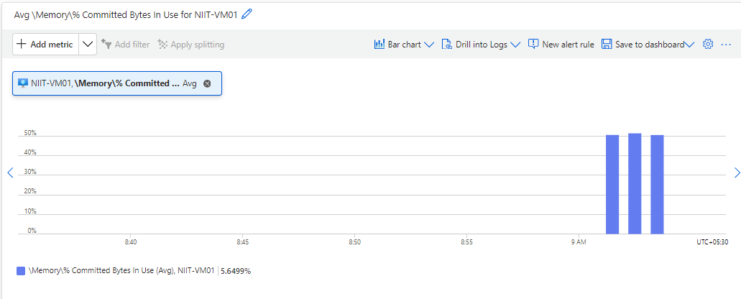

## Network in Utilization

Following is the **PROD-APPVM01** Network in Utilization for the report period 01st December – 31st December 2022

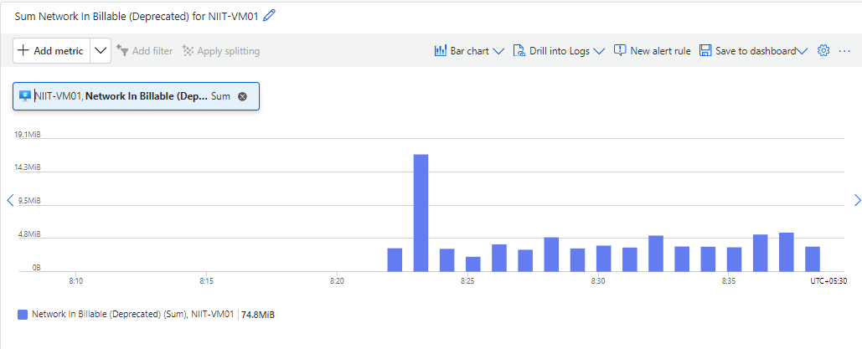

## Network Out Utilization

Following is the **PROD-APPVM01** Network Out Utilization for the report period 01st December – 31st December 2022.

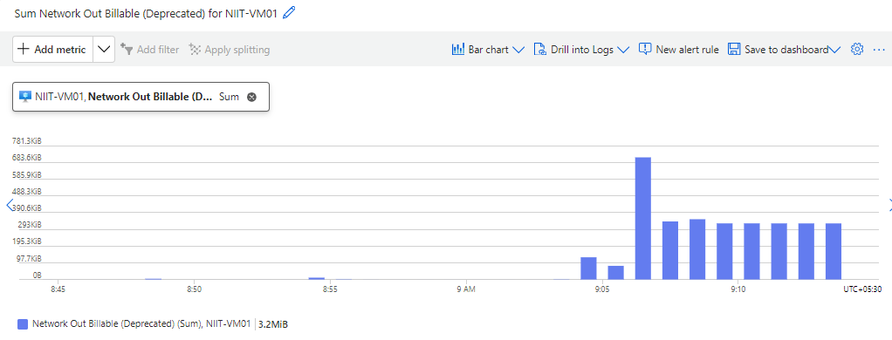

## VM Backup Status

Following is the **PROD-APPVM01** VM Backup Status for the report period 01st December – 31st December 2022.

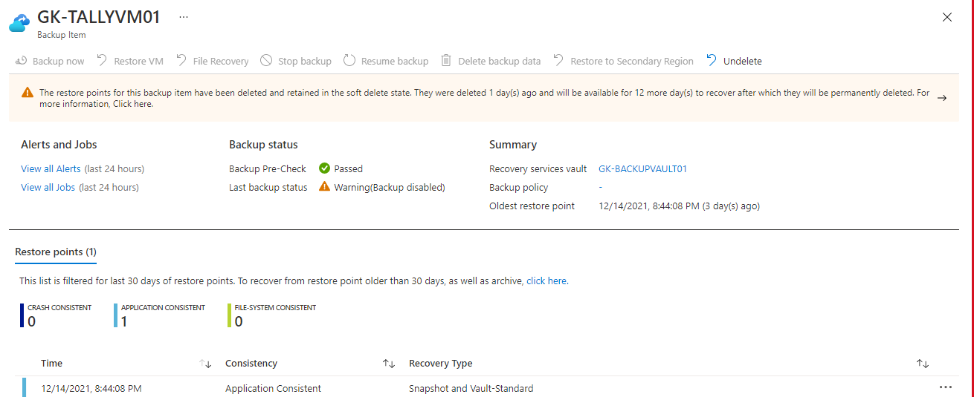

## Database Data Storage Chart.

Following is the **WBIC-PRODDBSRV01** Data Storage chart for the report period 01st December – 31st December 2022.

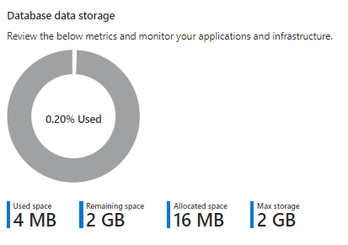

## SQL CPU Utilization Status.

Following is the **WBIC-PRODDBSRV01** CPU Utilization for the report period 01st December – 31st December 2022.

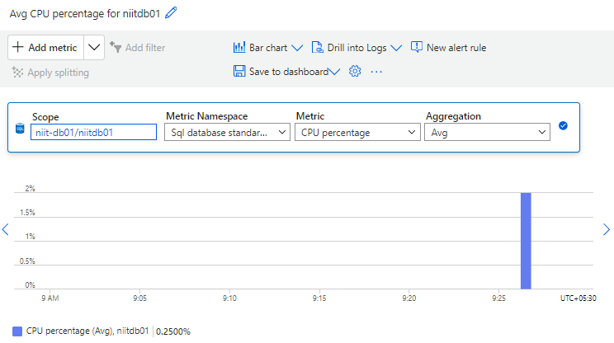

## SQL DTU Utilization Status.

Following is the **WBIC-PRODDBSRV01** DTU Utilization for the report period 01st December – 31st December 2022.

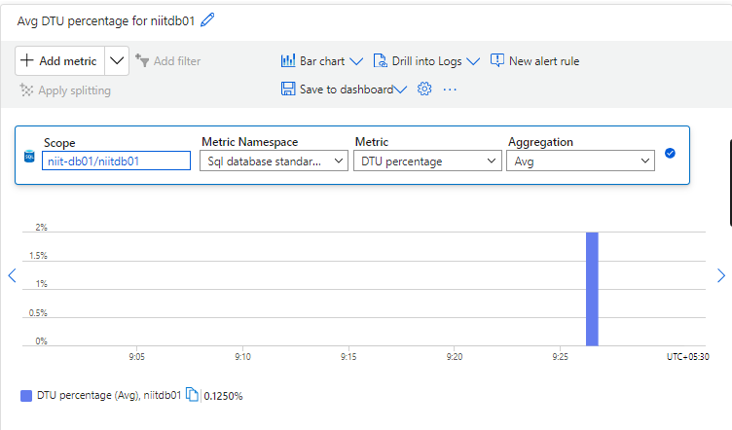

## SQL Backup Status

Following is the **WBIC-PRODDBSRV01** Database Backup Status for the report period 1rd December – 07th January 2023.

|  |  |  |
| --- | --- | --- |
| **SQL Server Name** | **Oldest Recovery Point** | **Latest Recovery Point** |
| WBIC-PRODDBSRV01 | 3rd Dec 2022 | 07th Jan 2023 |